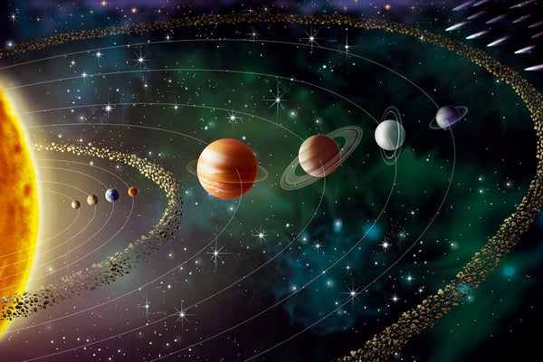
SEASON OF CREATION WEEK 3

Book of Nature: Celestial Spheres
June 23, 2024

Peace Lutheran Church West Seattle, Washington

Our themes and liturgy during this year’s Season of Creation are inspired by Barbara Mahany’s
The Book of Nature: The Astonishing Beauty of God’s First Sacred Text.
She writes: “Ancient peoples read the Book of Nature as the first sacred text, the text of all of creation, inscribed and unfurled by a God present always and everywhere.” God has “infused the natural world with symbol and meaning, and if only we read what’s there in the trees and the storms and the stars and the hives, we might more fully comprehend the Creator.”

We hold the second sacred text, the Bible, to be inspired — that is “God-breathed.”
The Book of Nature and the Book of Scripture provide us with inspiration which illuminates both.
Our Lutheran sacramental tradition celebrates the coming together of these great streams of tradition:
Water from the Earth, infused with God’s word of promise, becomes the source of our life in Christ.
Field ripened grain and grapes, infused with Christ’s promise to be present, nurture God’s people.
Over these three weeks we’ll explore three themes inspired by Barbara’s book:
Water’s Edge/Salish Sea—Wind & Weather—Celestial Spheres
GATHERING
P – Presider C – Congregation L - Lector A – Assisting Minister
ELW – Evangelical Lutheran Worship Hymnal ACS – All Creation Sings

PRELUDE Themes by Mozart and Bach Improvisation: Jon Lackey

WELCOME

CALL TO WORSHIP
The Hebrew phrase Sim lev! (Pay attention!) is a call to divine attention especially.
To read the Book of Nature and bump up against the One who breathed it and penned it,
the one holy practice, the necessary practice, is that of paying attention.

A Day is here!
C Sim lev!
P God is here!
C Sim lev!
A Awake, all creatures, awake to the light!
C Day is here! God is here!

P At every moment you draw this beautiful world to yourself, O God, breathing life into all that you have made. You love your creation like a mother her children.
C Your longing for life is relentless, like the perpetual light from our lifegiving Sun.
A Open our eyes to behold you, open our hands to touch you, open our minds to perceive you in the world that surrounds us, the Book of Nature, the first revelation of your Presence.
C Breathe into us the breath of life once more! Summon us through the waters!
P That we may behold your presence in every living thing;
that our hands may touch this world with blessing.
C Sim lev! Earth is filled with God’s presence!

GATHERING HYMN
The Night You Gave Us, God, Has Ended ACS #994

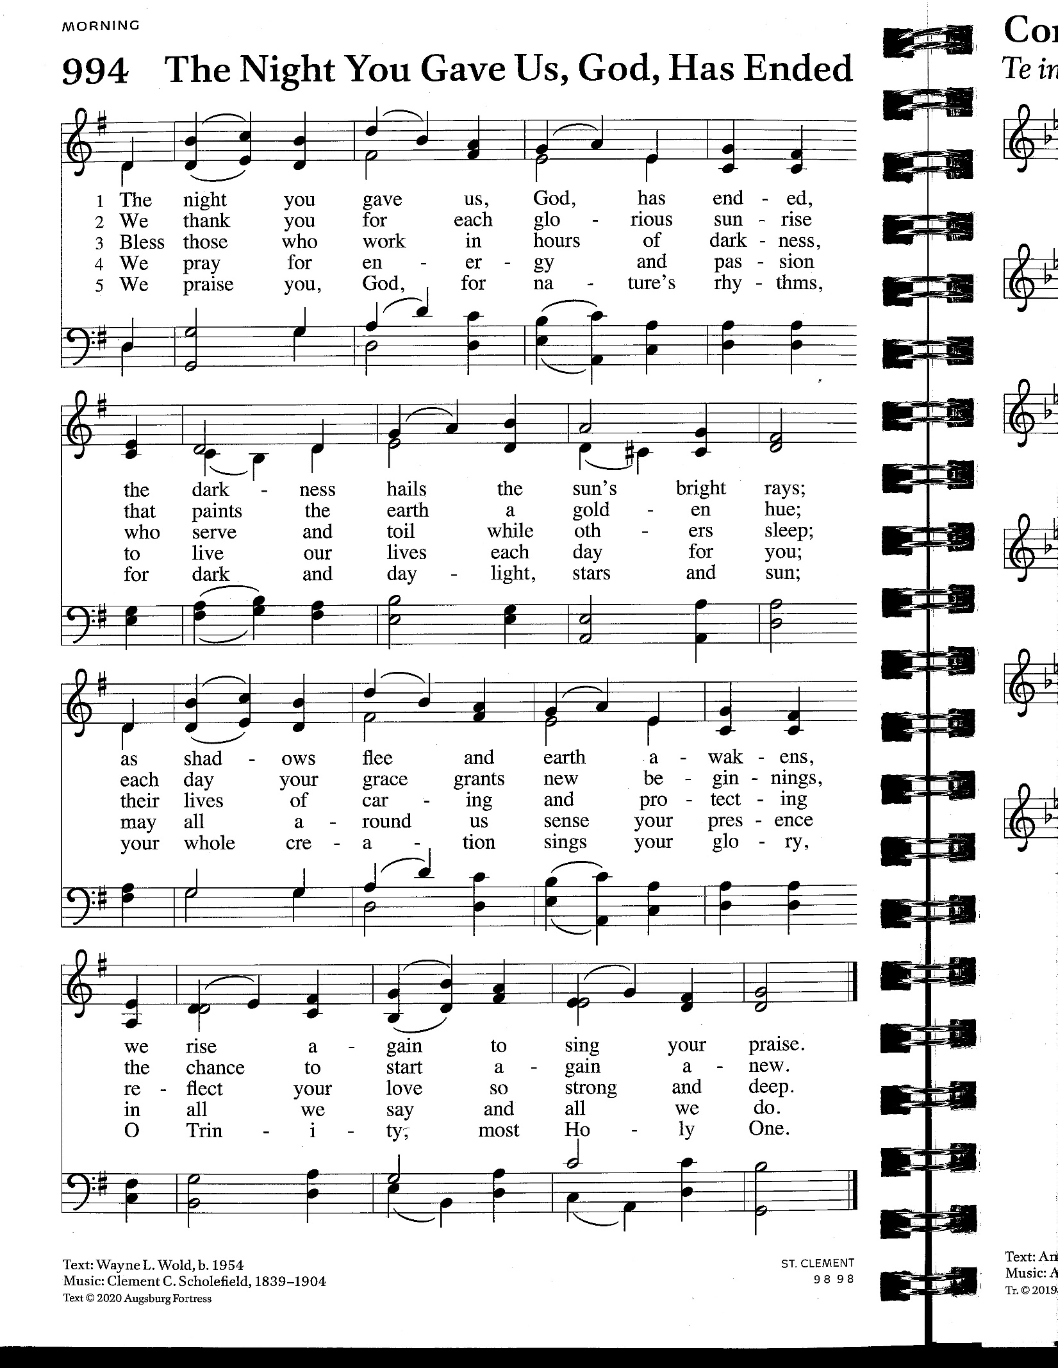
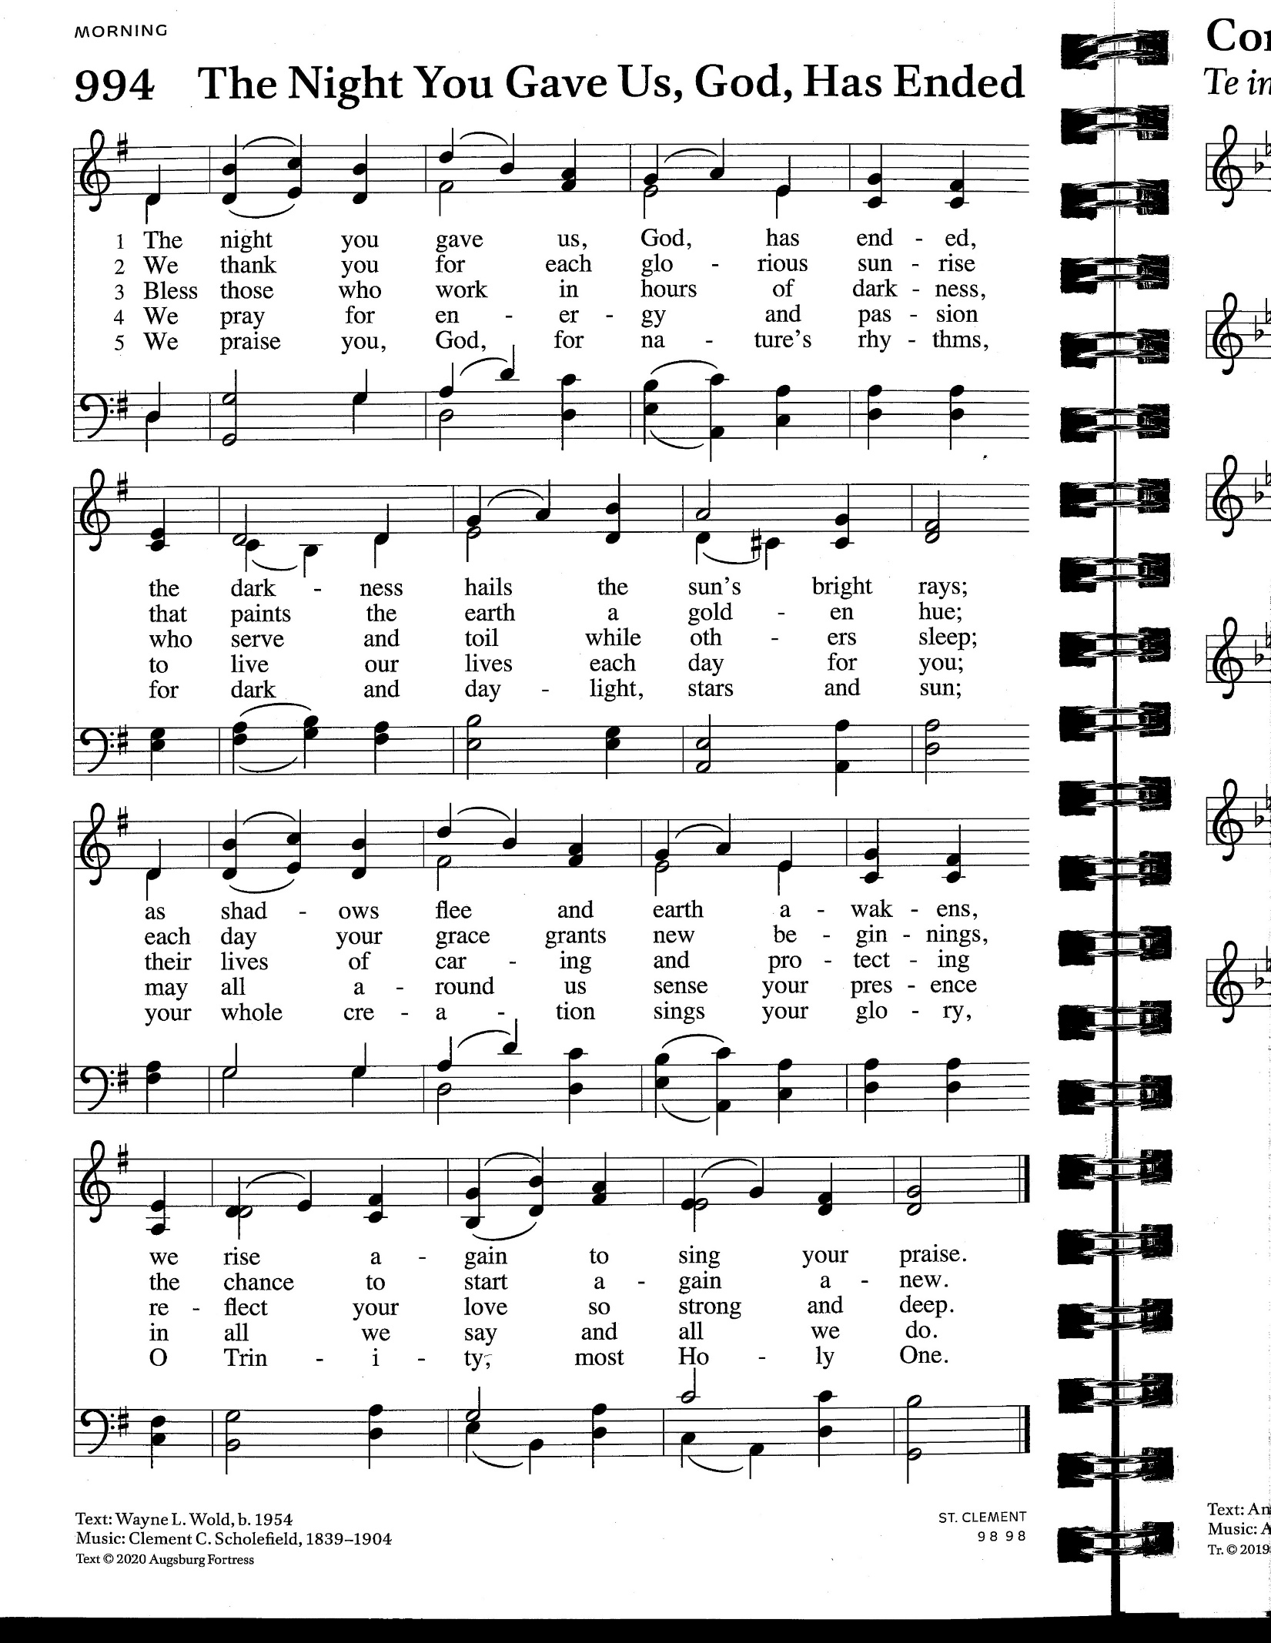

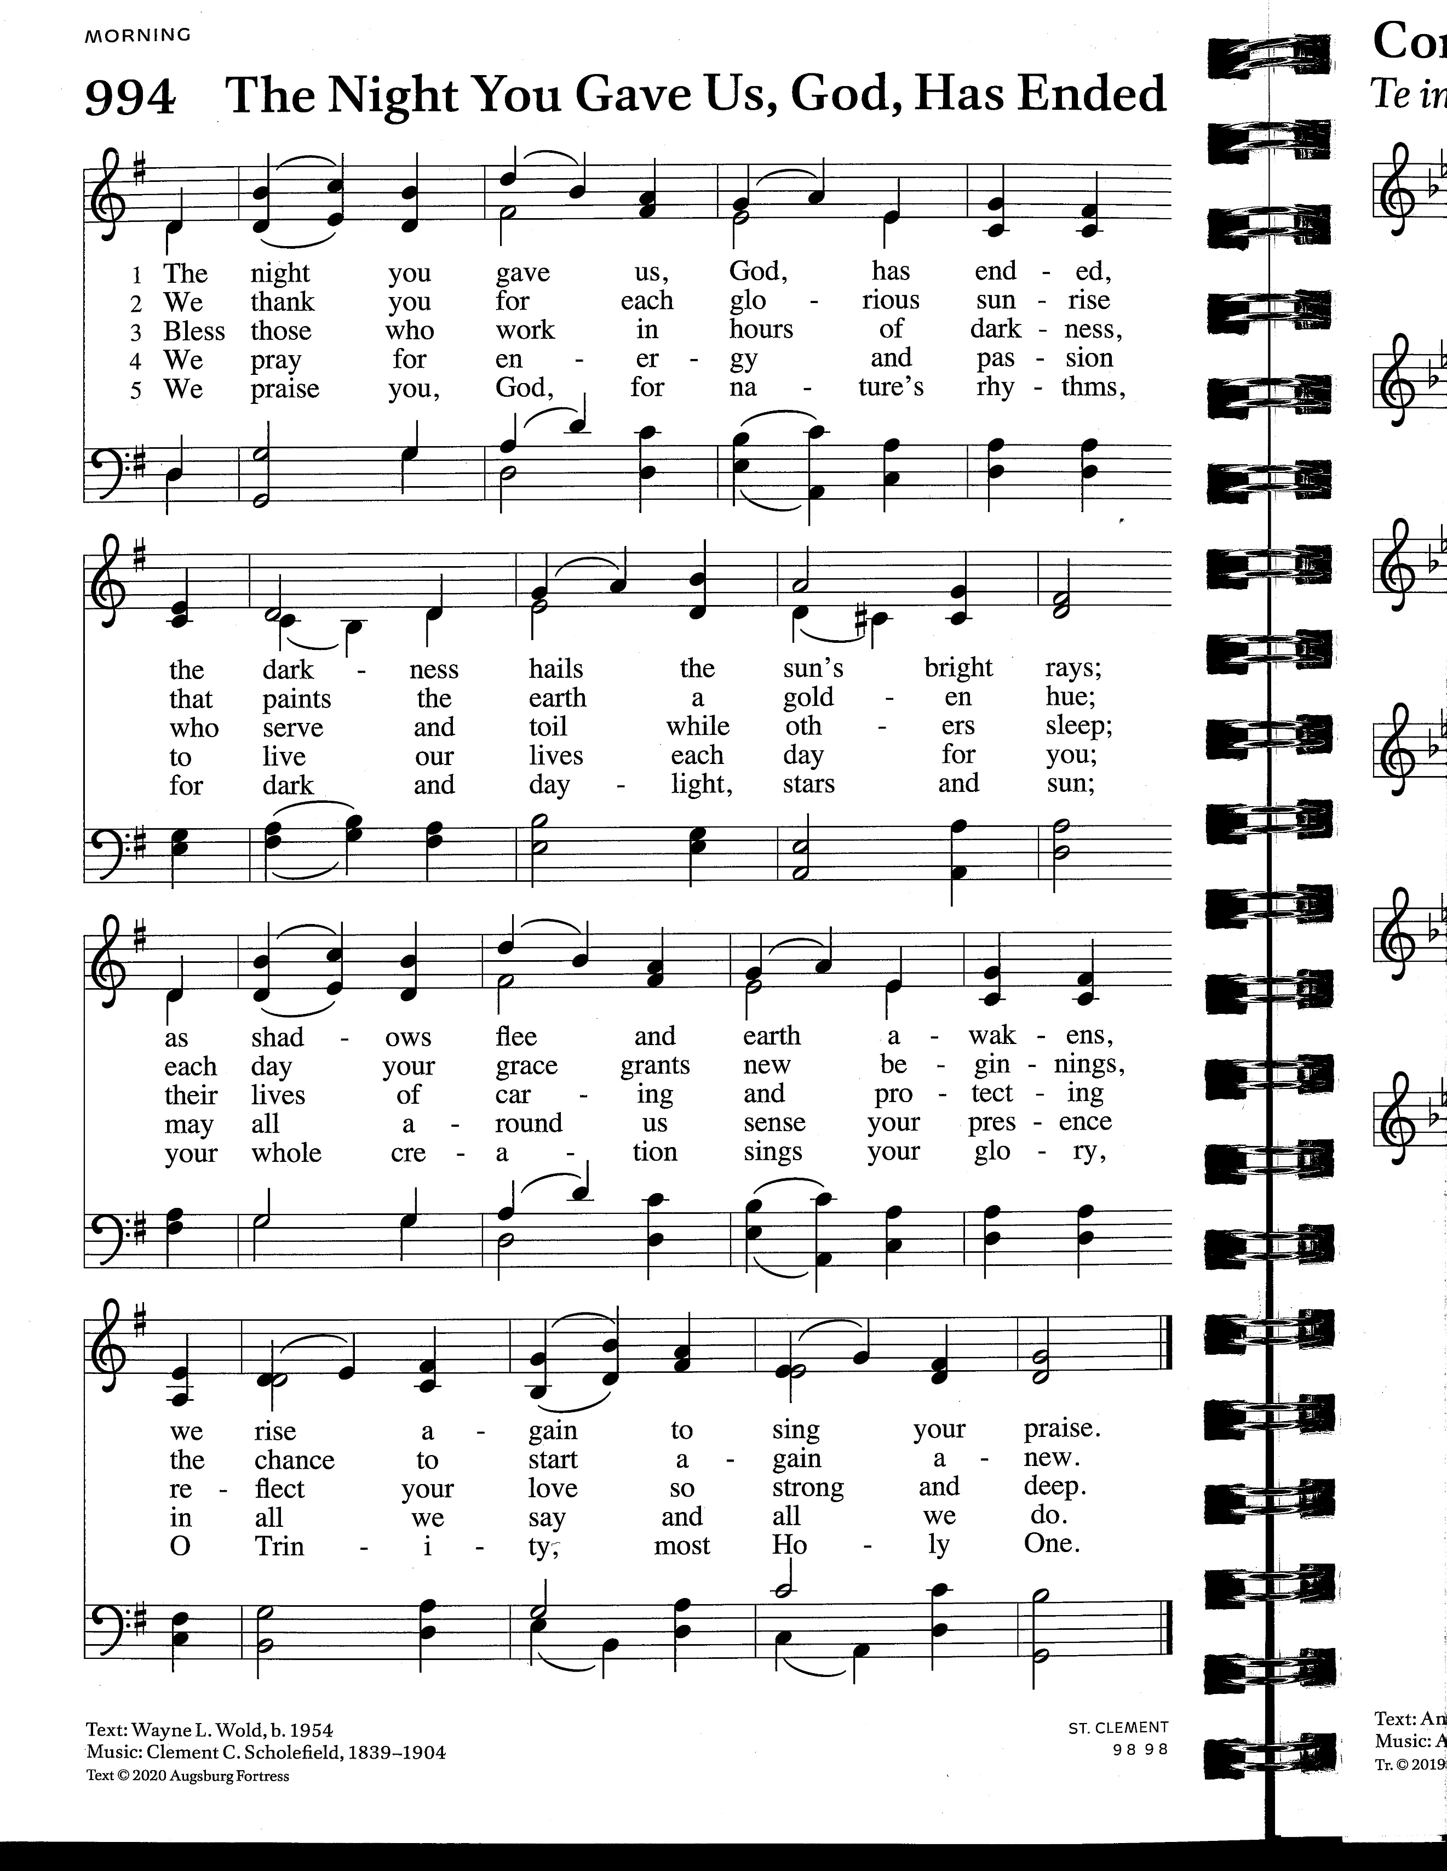

GREETING AND PRAYER OF THE DAY
P The grace, beauty, and abundance of the Creator be with you.
C And also with you.
P Let us pray. Creator God, our Source and Goal, in the beginning your Spirit brooded over the waters, fashioning a world which bears your imprint. Everywhere we look in earth, sea, and sky, we behold your image, calling forth our wonder, our respect, and our praise. Enable us to experience your living presence as we celebrate the wonders of the world that surround us. In the name of the Human One, whose life, death, and resurrection unites all things in heaven and Earth.
C Amen. Please be seated.

CONFESSION AND ASSURANCE At the font.
P “Pay attention,” God said. “Look for me in the Book of Nature; search for signs in the world which gave you birth. Plumb my presence in mountain forests, rock strewn rivers,
and tide pools along the Salish Sea. Seek me among flora & fauna of earth, sea, and sky.”
C “Pay attention,” God said. But we haven’t paid attention.
P Our energies have been fixed on relishing our ingenuity, boasting our superiority, exploiting Earth’s treasures to fulfill perceived needs. Along the way, we’ve missed so much, lost so much, damaged so much of God’s good creation, and for this, we are sorry.
C We are sorry. Forgive our inattention, O God. Open the Book of Nature to us again.
Give us the will to treat Earth with respect, care, and gratitude.

HYMN OF CONFESSION Before the Waters Nourished Earth ACS #1049, v. 1-3
Tune: St. Columba
- Before the waters nourished Earth or night imagined morning,
a Love conceived the universe and reveled in its forming.

- This Love remained as time revealed the loss of Eden’s glory
and, grieving, holds in memory each tragic human story.

- Despair, so deep it bears no name, or sorrows paralyzing
cannot revoke Love’s faithful claim to dwell within our dying.
ASSURANCE
P Hear this, all of you: From time beyond imagining, before starry cauldrons burst their bounds, seeding the universe with the elements of life, God has been loving you.
In the physics of grace, God’s love will not cease—neither for you nor for this Earth.
The gift of forgiveness means we are graced with the chance to begin again. Sim lev!
C We pledge ourselves to pay attention. Sim lev!

Before the Waters Nourished Earth ACS #1049, v. 4
- The Love that called creation good all goodness still is bringing.
This Love turns death again to life and silence into singing.

PASS THE HAT Earth Ministry Keah Calluccie

SACRED TEXTS

FIRST READING: Genesis 1:14-19 The Inclusive Bible Helen Hundley
At God’s command celestial spheres – Sun, Moon, and Stars – were set in the sky to provide light and to mark the seasons. The universe revealed to us in the 21st century is founded upon elements that emerged from stellar cauldrons after the Big Bang. This 1st generation of stars slow-cooked ingredients in “gigantic spherical crockpots,” then hurled their contents out into the cosmos, seeding life.

Then God said, “Now, let there be lights in the expanse of the sky! Separate day from night! Let them mark the signs and season, days and years, and serve as luminaries in the sky, shedding light on the earth.” So it was. God made the two great lights, the greater one to illumine the day, and a lesser to illumine the night. Then God made the stars as well, placing them in the expanse of the sky, to shed light on the earth, to govern both day and night, and separate light from darkness. And God saw that this was good. Evening came, and morning followed—the fourth day.

L Holy wisdom. Holy word. C Thanks be to God.

PSALM 148:1-13 Read responsively.
¹ Hallelujah! Praise the LORD from the heavens; praise God in the heights!
²Praise the LORD, all you angels; sing praise all you hosts of heaven!
³Praise the LORD, sun and moon; sing praise, all you shining stars!
⁴Praise the LORD, heaven of heavens, and you waters above the heavens!
⁵Let them praise the name of the LORD, who commanded and they were created.
⁶God made them stand fast forever and ever;
giving them a law that shall not pass away.
⁷Praise the LORD from the earth, you sea monsters and all deeps,
⁸fire and hail, snow and fog, tempestuous wind, doing God’s will;
mountains and all hills, fruit trees and all cedars!
¹⁰Wild beasts and all cattle, creeping things and flying birds;
¹¹ sovereigns of the earth and all peoples, princes and rulers of the world;
¹²young men and maidens, old and young together!
¹³Let them praise the name of the LORD, whose name only is exalted,
whose splendor is over earth and heaven.
SECOND READING: Colossians 1:15-17
In this early Christian confession, in language similar to the Prologue of the Gospel of John,
Christ is described in cosmic dimensions.
¹⁵Christ is the image of the invisible God, the firstborn of all creation; ¹⁶for in him all things in heaven and on earth were created, things visible and invisible, whether thrones or dominions or rulers or powers—all things have been created through him and for him. ¹⁷He himself is before all things, and in him all things hold together.

L Holy wisdom. Holy word. C Thanks be to God.

GOSPEL ACCLAMATION Please rise in body or spirit to receive the gospel. ELW #171

P The Gospel according to John, the 1st chapter.
C Glory to you, O Lord.

GOSPEL: John 1:1-5
In the poetic prologue to his gospel, John celebrates Jesus as the eternal Word who was with God from the beginning as co-creator; the cosmic Christ whose light brings life to all creation.
¹In the beginning was the Word, and the Word was with God, and the Word was God. ²He was in the beginning with God. ³All things came into being through him, and without him not one thing came into being. What has come into being ⁴in him was life, and the life was the light of all people. ⁵The light shines in the darkness, and the darkness did not overcome it.

L The Gospel of the Lord C Praise to you, O Christ.

CHILDREN’S MESSAGE Pastor Erik

MESSAGE Pastor Erik Kindem

HYMN OF THE DAY Song of the Sky tune: Abbot’s Leigh

1. Lord of suns and star exploding
Galaxies and swirling skies,
Where you chose to show your glory
Took the heavens by surprise.
Lord of solar winds and wisdom,
Super stars that blow our mind,
Choosing such a fragile planet
Hardly seems a grand design.
2. On this piece of stardust swirling,
On this spinning spot in space,
Life itself was born like music,
When you showed your hidden face.
What an honor to be chosen,
Silent planet blue and green,
Filled with glory, grace and gardens,
Where the breath of God is seen.

3. What is even more amazing
we have poisoned Earth like fools.
Help us change our way of living,
love the Earth and love her rules.
Help us stem the tide of traders
leaving Earth an empty store;
join us now Creator Spirit,
come renew your Earth once more.

AFFIRMATION OF FAITH
P Let us confess our faith.
C We believe in God who creates all things, who embraces all things,
who celebrates all things, who is present in every part of the fabric of creation.
We believe in God as the source of all life,
who baptizes this planet with living water, who heals all the wounds of Earth.
We believe in the book of Nature, the book of life unfolding,
the book revealing the mysteries of God’s wisdom.
We believe in Jesus Christ as the revelation and Wisdom of God,
joining the web of life as human flesh,
Jesus is the love of God immersed in the cosmos.
We believe in an Earth community,
a community where the lives of all creatures and habitats are interconnected.
We believe in Life forever, empowered by the breath of the Spirit of God,
connected with our cosmic Christ and celebrated by all creation.
We know this. And it is true.

PRAYERS OF INTERCESSION We Lift this Prayer ACS #1067
After each petition, the congregation responds with the refrain below.

Final refrain:

SACRED FEAST

THE PEACE
P The peace of the Lord be with you always.
C And also with you. Share a gesture of peace with your neighbors.

ANNOUNCEMENTS

OFFERING

OFFERTORY God of the Sparrow ELW #740
wa - ters How does the crea–ture say Beau - ty!
How does the crea - ture cry Praise!
God of the ground be-
2 God of the light - ning, God of the storm, God of the tem - pest
3 God of the pla - nets God of the stars God of all life un -
God of the ground be-
blast How does the crea-ture cry Ho - ly!
God of the ground be-
fold - ing How does the crea-ture say Won - der!
How does the crea - ture say Grace!
God of the ground be-
1 God of the sea - star, God of the clam, God of the ti - dal
How does the crea - ture say Thanks!
God of the ground be-

OFFERTORY PRAYER
A God, our Creator,
C Yours the seas, the wind, the skies! Ours the wonder, ours the cries!
Yours to give that we receive, ours to receive that we may give. Amen.
THE GREAT THANKSGIVING
P The Creator is with you.
C And also with you.
P Open your hearts!
C We open them to our Creator!
P Let us give thanks to the maker of heaven and earth.
C It is right to join with every creature in praising God.
P It is indeed right, our duty and our joy, to give you thanks, generous and loving God.
You chose to be born a human being, to become a part of Earth,
to suffer, die and to be raised from death to redeem humankind,
to renew creation, and to reconcile all born of Earth and the Spirit.
C Your presence is the living impulse in all things,
the Christ deep among us, filling every element and place;
filling the grain and the grape we share with you this day.
P Therefore with angels and archangels, saints and sinners, ancient voices in the forest,
high voices from the sky, deep voices from the sea, and the whole company of creation,
we proclaim your presence among us.
C Holy, holy, holy! God of all life!
Earth and sea and sky are full of your presence and glorify your name.

EUCHARISTIC PRAYER
P In the night in which he shared his final meal with his friends,
our Lord Jesus took bread, and gave thanks; broke it, and gave it to his disciples saying:
C Take and eat; this is my body given for you. Do this for the remembrance of me.

P Again, after supper, he took the cup, gave thanks, and gave it for all to drink, saying:
C This cup is the new covenant in my blood, shed for you and for all people for the forgiveness of sin. Do this for the remembrance of me.

P With this bread and cup, O God, we remember your Son Jesus, the first-born of your new creation. We remember his life lived for others and his death and resurrection, which renews the face of the Earth. Send your Spirit upon all who are gathered here and upon all creation. Satisfy the thirst of every living thing and fit us for service as stewards and keepers of all you have entrusted to us, through the same Lord Jesus Christ,
who taught us to pray:
C Our Father in heaven, hallowed be your name,
your kingdom come, your will be done, on earth as in heaven.
Give us today our daily bread. Forgive us our sins as we forgive those
who sin against us. Save us from the time of trial and deliver us from evil.
For the kingdom, the power, and the glory are yours, now and forever. Amen.

INVITATION TO COMMUNION
P The table is set! Come to the feast of life.
C Thanks be to God!

DISTRIBUTION
We commune processionally. Extend your hands to receive bread. A gluten free wafer is also available. Both wine (dark) and grape juice (light) are available in the ceramic cups. Place your empty cup in the box at the end of the front pew on your way back. Children are welcome to receive when their parents believe they are ready, with the support of the pastor. Any who prefer a blessing may cross their hands over their chest as they come forward.

COMMUNION HYMN
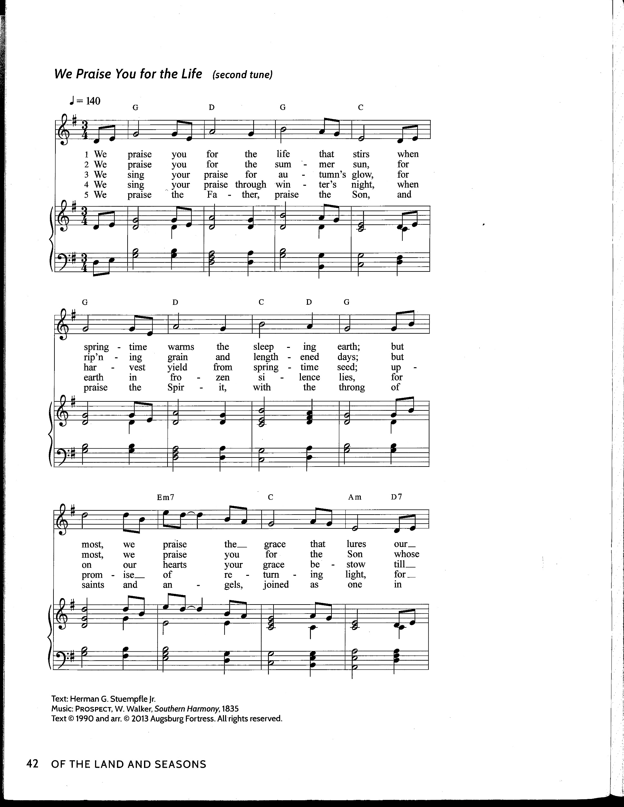
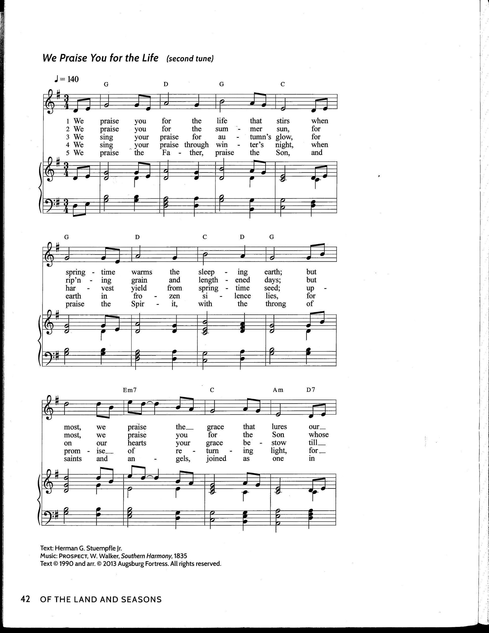
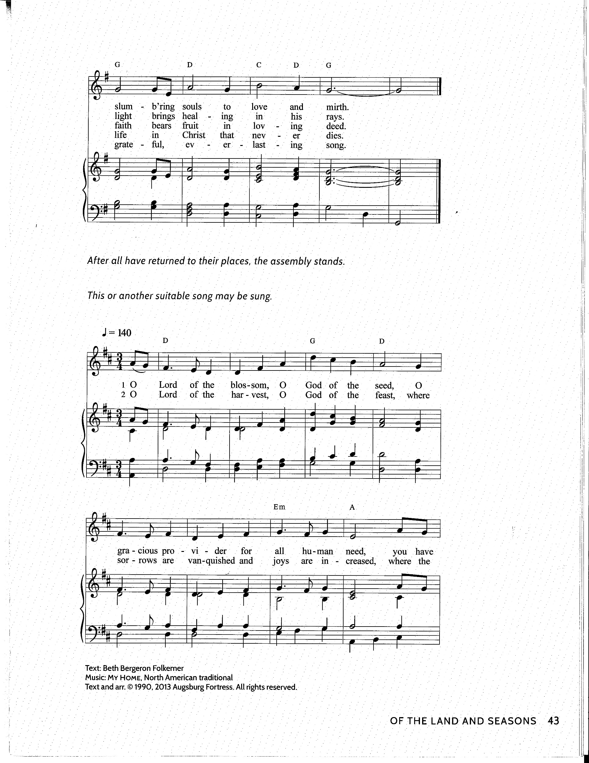
We Praise You for the Life that Stirs (From Land and Seasons Liturgy) Tune: Prospect

PRAYER AFTER COMMUNION
A Let us pray. May the penetrating power of Christ’s body and blood
reach deep into your heart, your mind, and your body to heal your wounds,
and through you, bring healing to Earth.
C Amen.

INTO THE WORLD

THE CALL
P Christ calls us to be rooted and grounded in love,
to serve Earth by caring for creation
to serve by caring for all creatures, habitats, and watersheds.
Will you care for creation?
C We will care for creation!
We will care for one another!
We will nurture our planet!
We will celebrate life!

SENDING HYMN ACS #1071
In Sacred Manner tune: Seattle
5 In sa - cred man - ner may we live a -
6 In sa - cred man - ner may we walk up -

mong the wise and lov - ing ones, sit hum - bly as at
on the fair and lov - ing earth, in beau – ty move, in

sa - ge’s feet, by four-legged, finned, and feath - ered ones. The
beau-ty love the liv - ing round that brought us birth. We
an - i - mals will teach. The an - I - mals will teach.
stand on ho - ly ground. We stand on ho - ly ground.

DISMISSAL
A Go in peace. Be astonished!
C Thanks be to God!

POSTLUDE Tune: Thaxted from “The Planets” Gustav Holst
Chris Kindem, Flute

CONTACT INFORMATION
8316 39th Avenue SW, Seattle, WA 98136 206-935-1962
Pastor Erik Kindem’s mobile phone number: 206-930-3172
Pastor Erik Kindem’s email: Pastor@PeaceLutheranSeattle.org
Peace Lutheran web page: www. PeaceLutheranSeattle.org
Kathleen Keyes Office Admin. Office@PeaceLutheranSeattle.org
Church Office hours: Tuesday through Thursday 10:00am-3:00pm
Nicole Klinemeier, Youth Director 206-427-6496
Jon Lackey, Minister of Music Music@PeaceLutheranSeattle.org

Find us on at People of Peace Lutheran

SERVING IN WORSHIP
Pastor Rev. Erik Kindem
Minister of Music Jon Lackey
Liturgical Assistant Janet Cruse
Acolyte Kimberly Simmons
Lector Helen Hundley
Children’s Sermon Pastor Erik
Greeters Ruth Eilers, Liz Hernandez
Ushers David Kehle, Randy Hernandez
Altar Care Boots Winterstein
Communion Assistants Sonja & Juliana Outlaw
Coffee Server Creation Care Team
Production Techs Dustin Smith, Alex Wren
Counters Kathleen Keyes, Randy Hernandez

OUR FINANCIAL STEWARDSHIP
At the Congregational Meeting on February 4, we embraced a plan for funding our mission in 2024. That plan anticipates offering income averaging $26,477 monthly. Thank you for your gifts which support God’s mission at Peace, in the larger community, and internationally through the ELCA!
Offering Income received June 2024
06/02/24 $ 4,145.00
06/09/24 $ 216.24
06/16/24 $ 640.00
Electronic $ 7,674.13
Total $12,675.37
Heating campaign total received to date: $25,475.00

SOURCES FOR TODAY’S LITURGY
TODAY’S LITURGY was created by Pastor Erik Kindem and the Peace Worship Team, with elements coming from a variety of sources. The overall inspiration is from, The Book of Nature, by Barbara Mahany. Other sources include: Norman Habel, creed, hymnody, and Great Thanksgiving; Feast of the Universe, compiled and edited by Anne Rowthorn. See permissions below for specific information.

THIS WEEK’S ACT FOR CREATION
You can add to Seattle tree canopy for free courtesy of Seattle’s Tree for Neighborhoods program! Applications open July 1, but you can sign up now to be notified for which trees will be available. To qualify, you must own property in Seattle, choose trees appropriate for the space, attend a planting and care workshop or webinar, and plant and properly care for your trees. Get the details at seattle.gov/trees/trees-for-neighborhoods.
Pray for Creation: We pray that our remarkable, stardust-composed bodies and the constancy of the celestial spheres in the sky be a reminder of God's unimaginable creativity and enduring care for us.

SEASON OF CREATION: JUNE 9 – 16 – 23
Our themes for this year’s Season of Creation are inspired by Barbara Mahany’s The Book of Nature: The Astonishing Beauty of God’s First Sacred Text.
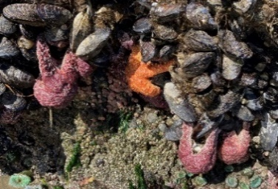
Our Week One theme: Water’s Edge, coincided with minus tides that were in Seattle last weekend and following worship we went to Lincoln Park Beach to join a naturalist from the Seattle Aquarium in exploring the tide flats.

In Week Two: Wind & Weather, we were joined via ZOOM by author BARBARA MAHANY, who shared with us during worship as well as afterward in the fellowship hall. Copies of Barbara’s book are available at Paper Boat Books.
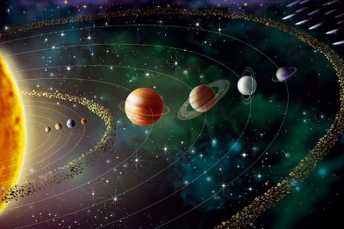
Our theme for today, Week Three, is Celestial Spheres. Sun, moon, and stars interact with Earth and shape the daily lives and rhythms of all of Earth’s inhabitants in ways both profound and mundane. These “spheres of influence” are part of the origin story of all Earthlings. An astonishment sample from Barbara:
“Orbital truths: planet Earth orbits around the sun at 64,800 miles per hour; our solar system—one described “like a merry-go-round unhinged, [that] spins, bobs, and blinks”—is downright slo-mo in comparison, gliding a mere 43,200 miles per hour along a course east of Hercules.”

PASS THE HAT THIS SUNDAY IS EARTH MINISTRY
"Earth Ministry transforms faith into action for the well-being of communities and the environment. We organize people of faith to advocate for strong environmental policies and provide strategic guidance to religious communities working toward environmental justice. Our Greening Congregations program was the first in the country to help houses of worship implement sustainable practices, and our Faithful Advocacy program is on the cutting edge of empowering clergy and lay leaders to speak out on public policy issues. Earth Ministry’s Washington Interfaith Power & Light (WAIPL) project organizes an interfaith religious response to climate change and is part of a national Interfaith Power & Light network that is 40 states strong and growing.” Keah Calluccie will be here to give us an update.

JUNE 30th GUEST PREACHER: REV. ANDY YEE
Assistant to the Bishop Rev. Andy Yee will visit us next week and serve as our guest preacher. Pastor Kindem will preside. If you want to learn more about what’s happening in our NW Washington Synod or would like to share feedback or comments, come to worship June 30.^{th}

WIN MEETING WEDNESDAY, JUNE 26 AT PEACE @ 7 PM
Westside Interfaith Network (WIN) will be meeting at Peace on 6/26 at 7 pm in the narthex. All are welcome! Contact Boots or Marcia for more information.

SEATTLE PRIDE PARADE SUNDAY, JUNE 30
We are proud to be a Reconciling in Christ congregation within a Reconciling in Christ synod - with many opportunities for you and your church family to join in and celebrate PRIDE this season!
﻿The NW Washington Synod will be marching in the Seattle PRIDE Parade on Sunday, June 30th. There is space for 200 walkers this year. To register, email Jill (jillbossen@gmail.com) with the name of your congregation leader, their contact info AND the number of committed walkers by June 17. Details about arrival time and location will be shared with the congregation leader when available.
ORDER SYNOD PRIDE BANDANAS! This year, we have RAINBOW Bandanas with the synod logo for sale! Wear them wherever and whenever you are involved in a PRIDE event near you!
They are fun, fashionable, and fabulous! Cost is $5 per bandana and all proceeds will go to the synod LGBTQIA+ Ministry Fund. Have your congregation place an order here: https://forms.gle/QPM1itMCzQR4HaseA Pick up at synod office during business hours (or at an agreed upon location & time)

UPCOMING WORSHIP SCHEDULE FOR JULY
Pastor Erik will be serving as Resource Pastor at Camp Lutherwood June 30 – July 5th. Rev. Mel Jacob will serve as preacher and presider on July 7th. Pastor Erik will return to the pulpit on July 14th, a service at which August Elliott, son of Elizabeth and Tyler Menstell Coyle, will be baptized.
Heidi Eilers will preach and preside on July 21st, with support of Bishop Wee. Janet Cruse will serve as keyboard musician. July 28th will be a hymn sing service, led by Boots Winterstein and Marian Christjaener, with Janet Cruse again at the keyboard. Pastor Paul Winterstein will preside at Eucharist.

PRAYER LIST
Please continue to remember the sick and home-bound of our congregation and others who have sought our prayers: Sick/Recovering: Cay Bell; Jan Burt; Ixchela Castaneda; Rick & Charlene Coulson; Mike & Marsha Davis; MaryAnne DeVry; Joe Flint; Bob Gaines; Verna Hernandez; Maria Iriarte; Mary Jacob; Jeff & Dolly; Mark Kindem; Ken Keyes; Norma Knight; Evelyn Martinez; Steve Metzler; Bill Morrell; Michelle Pierce; Jill Remsey; Joey Roberts; JoAnne Spangler; Pat Spangler; Scott Stenberg; Sean Stephens; Doris Stevens; Sarah Taylor; Karin & Wade VanSant; Pam Webber; Roger Wingfield; Inta Zagars; Audrey Zemke.
Homebound: Connie Benjamin; Marjorie Johnson; Lu Kramer; Jan Madsen
We express our Christian sympathy to: the Kegel family, Vicki Martinez and Dana Rice on the death of their close friend, Mary Kegel.
PROTOCOL FOR PRAYER LIST We will keep people on the prayer list for one month unless otherwise specified or unless you contact the Peace office to extend the time.

RECONCILING IN CHRIST AFFIRMATION OF WELCOME

Christ calls us to reconciliation and wholeness, in a world that can be filled with alienation and brokenness. In faithfulness to the Gospel and to our Lutheran heritage, we answer Christ’s call to be agents of healing and safety, particularly for people who have been marginalized by our society. As a Christian community, we invite all people to join us as we work to better understand the meaning of grace for our lives.
We welcome people of all sexual orientations and gender identities into the life and mission of our congregation.

PERMISSIONS
Affirmation of Faith from: Seven Songs of Creation: Liturgies for Celebrating and Healing Earth by Dr. Norman Habel, a Lutheran pastor, theologian, and architect of the Season of Creation.

The Night You Gave Us, God, Has Ended Text: Wayne L. Wold © 2020 Augsburg Fortress. Music: Clement C. Scholefield. Used by permission of OneLicense.net, License #A-708444, all rights reserved.

Before the Waters Nourished Earth Text: Jeannette M. Lindholm © 1996 Jeannette M. Lindholm, admin. Augsburg Fortress. Music: Irish melody. Used by permission of OneLicense.net, License #A-708444, all rights reserved.

Heleluyan Music: Muscogee (Creek) Indian; transc. Charles H. Webb © 1989 The United Methodist Publishing House, admin. The Copyright Company. Used by permission of OneLicense.net, License #A-708444, all rights reserved.

Song of the Sky Used by permission. May not be reproduced, distributed, or sold. From Seven Songs of Creation: Liturgies for Celebrating and Healing Earth, 2004, The Pilgrim Press.

For the Wholeness of the Earth (We Lift This Prayer) Text and music: Bret Hesla © 2017 Bret Hesla, admin. Augsburg Fortress. Used by permission of OneLicense.net, License #A-708444, all rights reserved.

God of the Sparrow Text: Erik P. Kindem © 2024, inspired by Jaroslav J. Vajda. Music: Carl F. Schalk © 1983 GIA Publications, Inc. Used by permission of OneLicense.net, License #A-708444, all rights reserved.

We Praise You for the Life Text: Herman G. Stuempfle Jr. © 1990 Augsburg Fortress. Music: PROSPECT, W. Walker, Southern Harmony, arr. hymnal version © 2013 Augsburg Fortress. Used by permission of OneLicense.net, License #A-708444, all rights reserved.

In Sacred Manner Text: Susan Palo Cherwien © 1990 Susan Palo Cherwien, admin. Augsburg Fortress. Music: Robert Buckley Farlee © 1997 Augsburg Fortress. Used by permission of OneLicense.net, License #A-708444, all rights reserved.

Thaxted from "The Planets" Music: Gustav Holst. Public domain

